**DAILY ONLINE ACTIVITIES SUMMARY**

|  |  |  |  |  |  |  |  |  |
| --- | --- | --- | --- | --- | --- | --- | --- | --- |
| **Date:** | **08/06/2020** | | | | | **Name:** | **Manish B Shriyan** | |
| **Sem & Sec** | **8th sem B sec** | | | | | **USN:** | **4AL16CS131** | |
| **Online Test Summary** | | | | | | | | |
| **Subject** | | **SMS** | | | | | | |
| **Max. Marks** | | **60** | | **Score** | | | **60** | |
| **Certification Course Summary** | | | | | | | | |
| **Course** | **Introduction to Cloud** | | | | | | | |
| **Certificate Provider** | | | **Cognitive Class** | | **Duration** | | | **3 Hours** |
| **Coding Challenges** | | | | | | | | |
| **Problem Statement:**  **C Program to Generate All the Set Partitions of n Numbers Beginning from 1 and so on** | | | | | | | | |
| **Status: Solved** | | | | | | | | |
| **Uploaded the report in Github** | | | | | **Uploaded** | | | |
| **If yes Repository name** | | | | | **ManishShriyan** | | | |
| **Uploaded the report in slack** | | | | | **Yes** | | | |

Online Test Details:

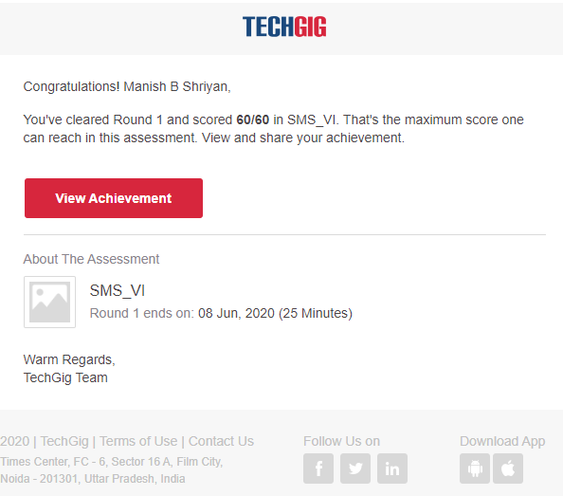

Certification Course Details:

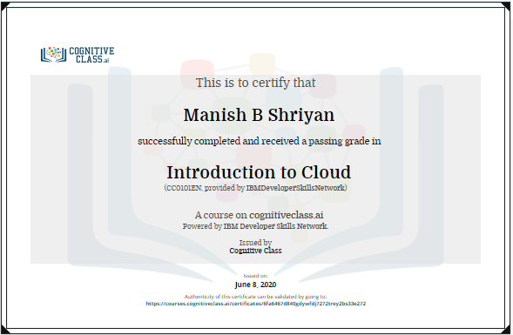

Coding Challenges Details:

|  |
| --- |
|  |
|  |  |
|  |  |
|  |  |
|  |  |
|  |  |
|  |  |
|  |  |
|  |  |
|  |  |
|  |  |

#include<stdio.h>

void printArray(int p[], int n)

{

for (int i = 0; i < n; i++)

printf("%d ",p[i]);

printf("\n");

}

void partition(int n)

{

int p[n], true=1;

int k = 0;

p[k] = n;

while (true)

{

printArray(p, k+1);

int rem_val = 0;

while (k >= 0 && p[k] == 1)

{

rem_val += p[k];

k--;

}

if (k < 0) return;

p[k]--;

rem_val++;

while (rem_val > p[k])

{

p[k+1] = p[k];

rem_val = rem_val - p[k];

k++;

}

p[k+1] = rem_val;

k++;

}

}

int main()

{

int n;

printf("Enter the number: ");

scanf("%d",&n);

partition(n);

return 0;

}